DEVELOPMENT OF A SHORELINE MAPPING METHOD USING THE SENTINEL-1 SATELLITE IMAGE ACQUIRED ON THE EAST COAST OF KOREA

Yun-Jae Choung*¹
¹Geospatial Research Center, Geo C&I Co., Ltd.
3rd Fl., Junmyung Bldg., 435, Hwarang-ro, Dong-gu, Daegu, 41165, Republic of Korea
Email: chyj@geocni.com

KEY WORDS: SAR, Sentinel-1, Shoreline, Image thresholding

ABSTRACT: The development of a shoreline mapping method using the remote sensing datasets is necessary for describing the detailed coastal shapes, preventing coastal erosions and protecting the coastal properties in wide coastal zones without human access. In previous research, the optical remote sensing data with the multispectral bands were generally used for mapping shorelines due to the optical datasets' relatively easy processing and analysis works. However, the utilization of optical remote sensing data is significantly limited for monitoring the wide coastal zones sustainably because the quality of these data is negatively affected by weather conditions such as heavy clouds. This research proposed a shoreline mapping method using the Sentinel-1 satellite image acquired using the C-band SAR (Synthetic Aperture Radar) sensor through the following steps. First, the Sentinel-1 GRD (Ground Range Detected) dataset acquired on the east coast of Korea was downloaded from the Copernicus Open Access Hub portal. Next, the orbit information of the downloaded Sentinel-1 GRD product was modified using the accurate position and velocity information of the Sentinel-1 satellite. Then, the thermal and border noises in the Sentinel-1 GRD product were removed. Then, the given Sentinel-1 GRD product was radiometrically calibrated to convert the image intensity values into the sigma naught values. Range doppler terrain correction was then operated to correct the geometric distortions in the Sentinel-1 GRD product. Then the unitless value of the backscatter coefficient was converted into the unit value with dB using logarithmic information. The binary image separating the land and water features was generated from the refined Sentinel-1 GRD product by the image thresholding. Finally, the boundary located between the land and water features in the binary image was selected as the shoreline. The proposed method was superior to detecting the accurate shoreline position in the Sentinel-1 GRD products acquired on the east coast of Korea.

INTRODUCTION
A shoreline is defined as “the edge of a sea, lake, or wide river” (Cambridge Dictionary, 2023). Shoreline mapping is necessary for guiding the land-use decisions, monitoring the climate changes, conservating the environments, assessing the hazards and managing the resources in coastal areas (Moore 2000). Satellite imagery with high resolution had found extensive application in shoreline mapping endeavours, owing to its advantages in capturing both geometric and surface data from coastal areas without the need for human presence (Choung and Jo, 2017). Satellite imagery is categorized into two main types: optical imagery, which utilizes multispectral bands, and microwave imagery, which employs Synthetic Aperture Radar (SAR) bands. In previous research, the optical imagery has been used for mapping shorelines, because the optical sensors can identify the various land cover types including water and land features in coastal areas. However, due to the characteristics of the optical sensors, the optical imagery can contain the cloud covers that interrupt the detecting the shoreline positions in these areas. This research proposes a methodology for shoreline mapping using the SAR satellite imagery that are not affected by the atmospheric conditions such as clouds.

DATASET AND STUDY AREA
The study area chosen encompasses a 50-kilometer stretch along the eastern coast of Korea. The eastern coast of Korea annually experiences coastal erosion, attributed to a combination of natural and human-induced factors (Lim et al, 2023). We employed the Sentinel-1 Ground Range Detected (GRD) dataset, derived by utilizing the C-band SAR sensor with the IW (Interferometric Wide) swath mode, which was acquired in the study area on 23 August 2023.

METHODOLOGY
This section illustrates the procedure for mapping the shorelines using the proposed methodology that includes the multiple steps such as acquisition of the Sentinel-1 GRD dataset, pre-processing of the Sentinel-1 GRD dataset and extraction of the shorelines from the pre-processed Sentinel-1 GRD dataset.

Acquisition of the Sentinel-1 GRD Dataset
The Sentinel-1 GRD dataset was downloaded through the Copernicus Open Access Hub portal (https://scihub.copernicus.eu/), and Figure 1 shows the Copernicus Open Access Hub portal for downloading the Sentinel satellite imagery.

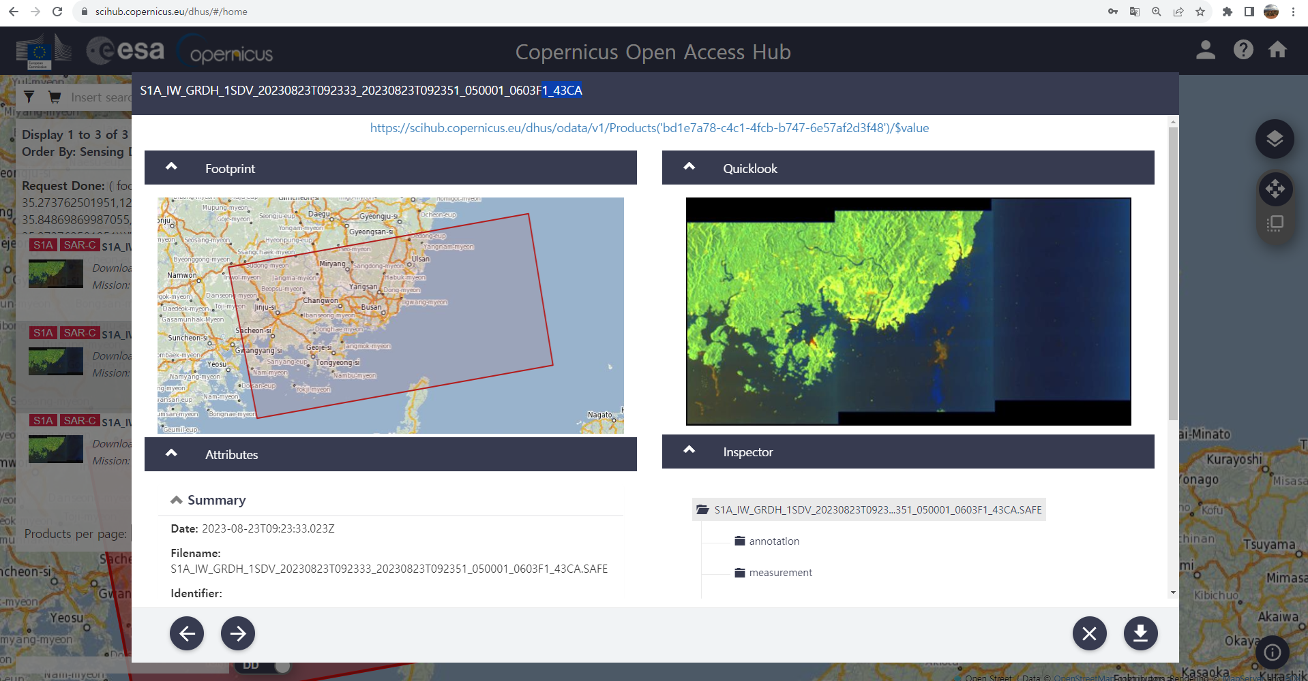
Figure 1. Copernicus Open Access Hub portal (https://scihub.copernicus.eu/).

Preprocessing of the Sentinel-1 GRD Dataset
After the Sentinel-1 GRD dataset was downloaded, the pre-processing of the dataset proceeded through the following steps. First, the orbit file of the downloaded dataset was employed to provide accurate satellite position and velocity information. Then, the noise effects caused by the thermal and border noise were removed by using the thermal noise removal operator and the border noise removal operator provided in the SNAP software. Subsequently, the calibration was conducted to transform the digital pixel values into radiometrically calibrated SAR backscatter measurements. In the calibration step, the image intensity values were converted into the sigma nought values. Next, the terrain correction was carried out for removing the geometric distortions using the Digital Elevation Model (DEM) and bilinear interpolation. During the final stage of the pre-processing procedure, the dimensionless backscatter coefficient underwent a conversion into decibels (dB) through a logarithmic transformation. Figure 2 shows the pre-processed Sentinel-1 GRD dataset.

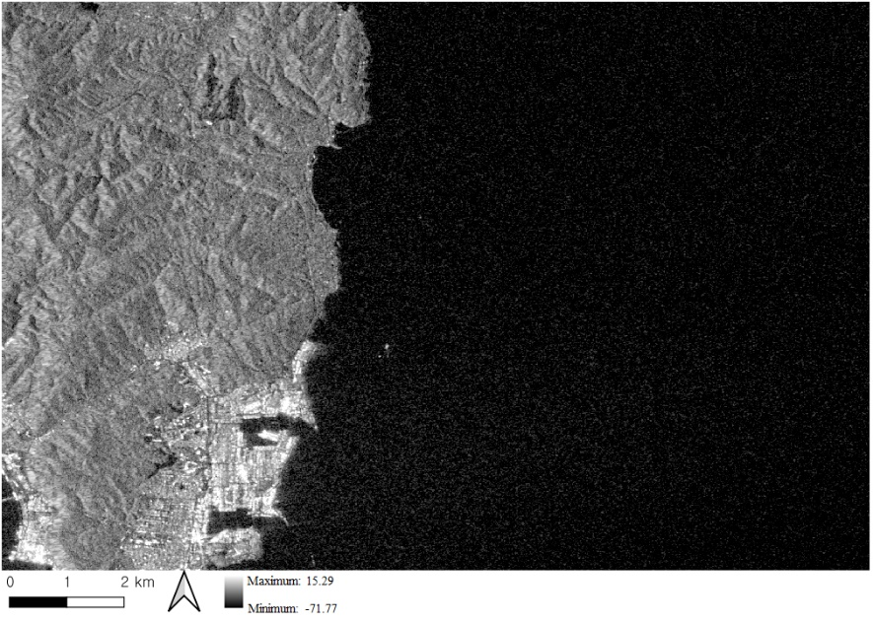
Figure 2. Pre-processed Sentinel-1 GRD dataset.

Extraction of the Shorelines from the pre-processed Sentinel-1 GRD Dataset
The image thresholding was employed for binarizing the land features and the water features in the pre-processed Sentinel-1 GRD dataset.

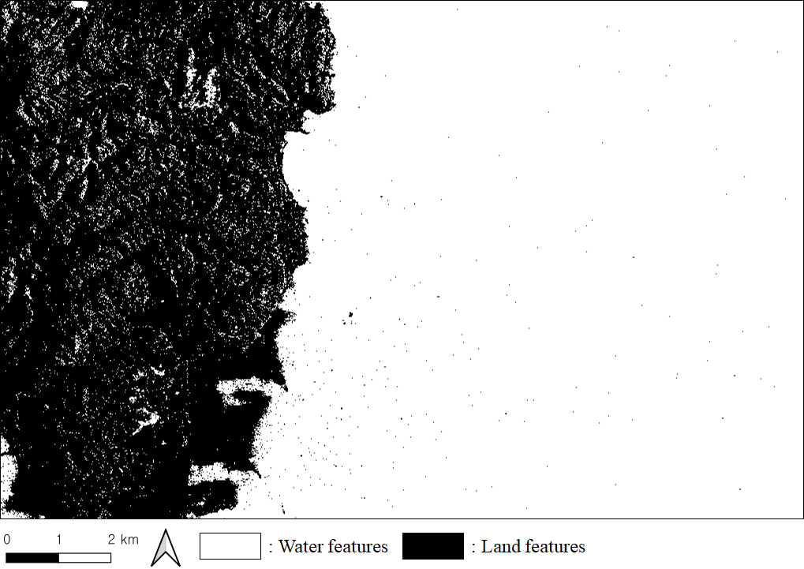
Figure 5. Binarized image for identifying the land features and the water features in the pre-processed Sentinel-1 GRD dataset.

In the final step, the boundary located between the land features and the water features in the binarized image was extracted and selected as the shorelines.

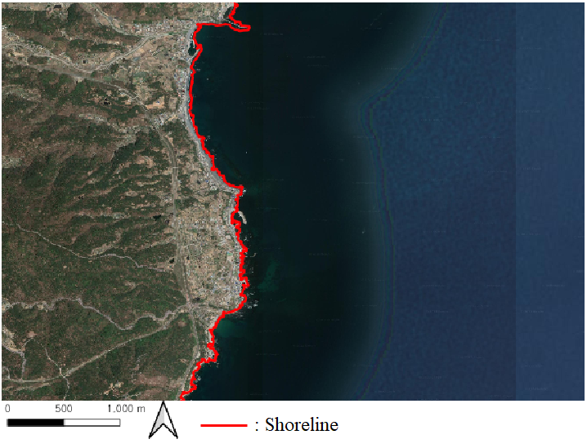
Figure 6. Shorelines extracted from the Sentinel-1 GRD dataset.

RESULTS
The given Sentinel-1 GRD dataset provides the two polarizations such as the VV (Vertical to Vertical) and the VH (Vertical to Horizontal). In this research, the proposed methodology was employed into the VV and the VH, respectively. Hence, the different shorelines were separately extracted from the VV and the VH. In future research, the statistical results for comparing the different shorelines separately generated from the VV and the VH would be computed to determine the more appropriate polarization for mapping the shorelines.

Acknowledgements
This research was supported by Korea Institute of Marine Science & Technology Promotion(KIMST) funded by the Ministry of Oceans and Fisheries, Korea(20180456).

References
Cambridge Dictionary. 2023. Shoreline. Available at: https://dictionary.cambridge.org/dictionary/english/shoreline (Accessed: 1 September 2023).
Choung, Y.-J. and Jo, M.-H. 2017. Comparison between a Machine-learning-based Method and a Water-index-based Method for Shoreline Mapping Using a High-Resolution Satellite Image Acquired in Hwado Island, South Korea. Journal of Sensors, 2017, pp.8245204.
Lim, H.S., Lee, H.J., Kim, D. and Hong, S. 2023. Beach erosion along the eastern coast of Korea: A brief review. Journal of Coastal Research, 39(1), pp.181-190.
Moore, L.J. 2000. Shoreline Mapping Techniques. Journal of Coastal Research, 16(1), pp.111-124.

